# CS 255 System Design Document Template

Joseph Grzywinski

This template lays out all the different sections that you need to complete for Project Two. Each section has guidance to prompt your thinking. You will need to continually reference the interview transcript as you work to make sure that you are addressing your client’s needs. There is no required length for the final document. Instead the goal is to complete each section based on what your client’s needs are. Remove this note when you are finished, and replace all bracketed text with the relevant information.

## UML Diagrams

### UML Use Case Diagram

*[In Module Six, you were asked to complete a use case diagram based on your system design. If you would like to make any adjustments to your diagram, please do so. Please insert your use case diagram here. Check to make sure that you included appropriate components and symbols and that your design meets the client’s needs.]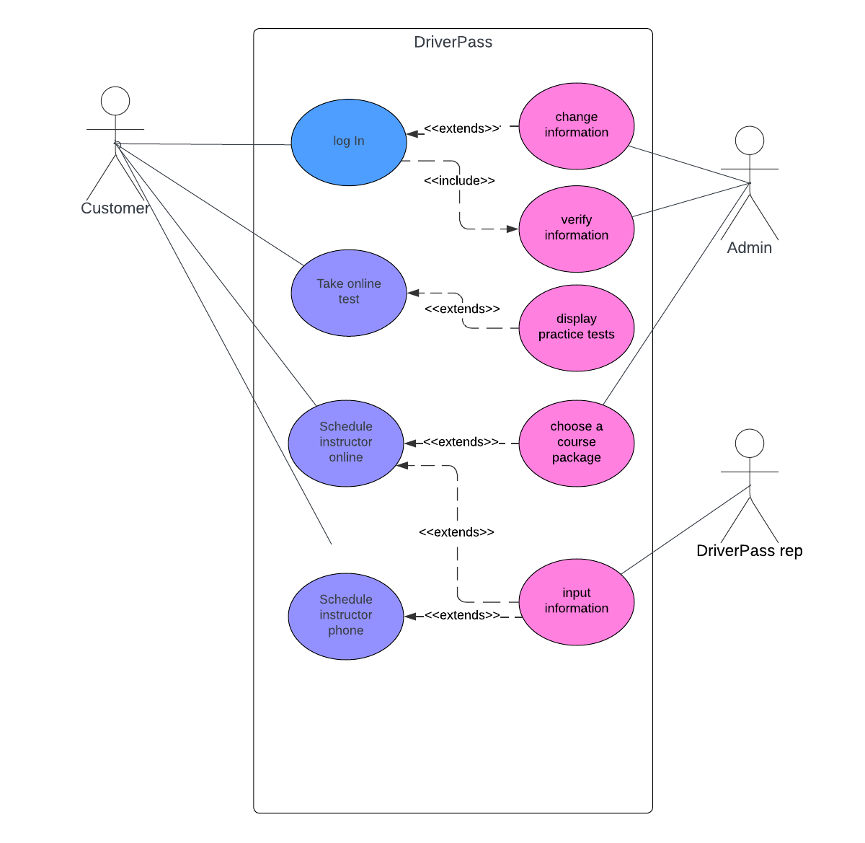*

### UML Activity Diagrams

*[You were asked to choose* ***two*** *use cases and create* ***two*** *activity diagrams, one for each use case. Please insert* ***both*** *of your activity diagrams here. Check to make sure that you included appropriate components and symbols and that your design meets the client’s needs.]*

### UML Sequence Diagram

*[You were asked to create a sequence diagram based on* ***one*** *of the use cases you chose. Please insert your sequence diagram here. Check to make sure that you included appropriate components and symbols and that your design meets the client’s needs.]*

### UML Class Diagram

*[You were asked to create a class diagram based on the different classes and attributes needed for your system design. You are* ***not*** *required to include methods, but you may if you wish. Please insert your class diagram here. Check to make sure that you included appropriate components and symbols and that your design meets the client’s requirements.]*

## Technical Requirements

*[Based on the diagrams you have created, describe the technical requirements of your system. These requirements should address the required hardware, software, tools, and infrastructure necessary for your system design.]*

To make an effective application to accomplish all that was documented in the diagrams and in the business, document created for DriverPass, the company will need to have to have an administrator available to keep track of all customer account activity. To accomplish this the company will need to implement a hierarchy or logins to distinguish between a normal representative and the administrator who will have access to customer passwords and usernames. The company also mentioned wanting to have a cloud-based application which means they will have to consider a cloud service to base their application from to connect to our front-end design that we have laid out here in the diagrams. This will help determine what language and framework we can build the application in. The customer will also need to determine what type of database they would like to implement into the design so they can keep track of user information such as usernames, passwords, test scores, and other personal information that needs to be kept securely for future use.